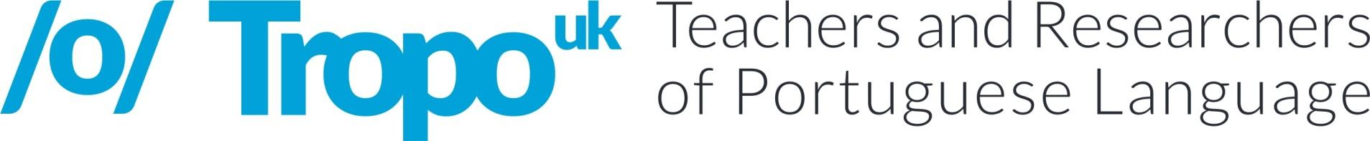

I Conferência TROPO UK
Call for Papers
#TROPOukCONF

TROPO UK - The Association for Teachers and Researchers of Portuguese in the UK - is pleased to announce its 1st Annual Conference on the theme of ‘Português Língua Global’ that will take place on Saturday, the 15th June 2019 at King’s College London.

In this one-day event, we want to acknowledge Portuguese as a global language given the number of speakers and its geographical reach as well as reflect on the specificities of its variants. The aim of the conference is to provide a forum for researchers and teachers to present and discuss current studies in linguistics, language acquisition, literary and cultural studies, learning and teaching methodology and their possible links to classroom practice. The conference seeks to contribute to suitably informed teaching and also to serve as a platform for practitioners to report back on the rich and meaningful everyday practices that they have put in place.

The conference will be an opportunity for sharing excellent or innovative research and practice in teaching and learning Portuguese. We welcome pedagogic research and practical case studies on aspects of Portuguese teaching and learning at all levels of education from pre-school to Higher Education, including community schools. Additionally, we invite submissions for research papers on any aspect of linguistics, language acquisition and literary and cultural studies with potential implications for the teaching of Portuguese as additional, foreign, heritage or second language.

Sub-themes of the conference:
- One global language, several variants: classroom challenges and how to address them.
- Reflection on teaching language and culture or language through culture, including using literary texts, films and CLIL.
- Design and evaluation of textbooks and other teaching materials, including digital resources.
- Effective methodologies and L&T approaches to Portuguese, including student-centred learning, active learning and task-based language teaching.
- Uses and effectiveness of technologies in language learning and teaching, including online autonomous language learning.
- Effective programme and syllabus design.
- Assessment for learning and assessment of learning, including international proficiency exams of Portuguese as a Foreign Language (CELPE-Bras and CAPLE).

- Policies in the promotion, projection and diffusion of Portuguese and cultures of Portuguese-speaking countries.
Advisory Committee:
Isabel Margarida Duarte (Universidade do Porto)
João Silvestre (King’s College London)
Luís Gonçalves (AOTP – American Organization of Teachers of Portuguese, USA)
Patrick Rebuschat (University of Lancaster)
Phillip Rothwell (University of Oxford)
Viviane Bagio Furtoso (SIPLE - Sociedade Internacional de Português Língua Estrangeira)

Abstract submission and participation formats:
We welcome submissions for:
- 20-minute paper presentation (max. 300-word abstract)
- posters (300-word abstract)
- 80-minute workshop (max. 500-word abstract, including rationale, learning outcomes and facilities required)
- 80-minute panels (max. 600-word abstract, three 20-minute papers is recommended to allow time for discussion)

Abstracts must be submitted at the event webpage: tropouk.weebly.com/abstract-submission.html
The languages of the conference are Portuguese and English.

Important dates:
Abstract submission - EXTENDED DEADLINE: *1st March 2019*
Notification of acceptance: 15th April 2019
Programme release: 3rd June 2019
Registration opens: 15th April
Early bird registration deadline: 7th May
General registration deadline: 3rd June

Participation fees*:

 | Early bird (members) | Early bird** | Standard rate (members) | Standard rate**
Presenters | £50 | £70 | £60 | £80
Other delegates | £25 | £45 | £35 | £55
*Only members with an up-to-date membership can participate. Membership open to all teachers and researchers of Portuguese language worldwide. To become a TROPO member go to tropouk.weebly.com.
**Includes membership fee.

Organising Committee:
Ana Reimão (University of Liverpool)
Conceição Pereira (Newcastle University)
Daniela Mittelstadt (King’s College London)
Regina Duarte (Instituto Camões)
Sofia Martinho (University of Leeds)

With the kind support of:
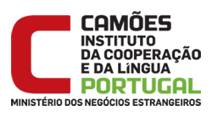 | 